ASR 3555 – Oversupply action plan

Operation to perform WMS shipment validation for SAP Confirmed TO against WMS packed item at Shipment#, TO#, SKU, Batch# and Qty.
(regardless the TO line#)

Added modules:
Detail refer to WMS user guide

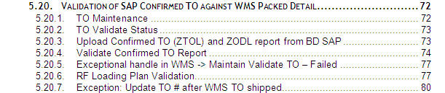

Sample report:
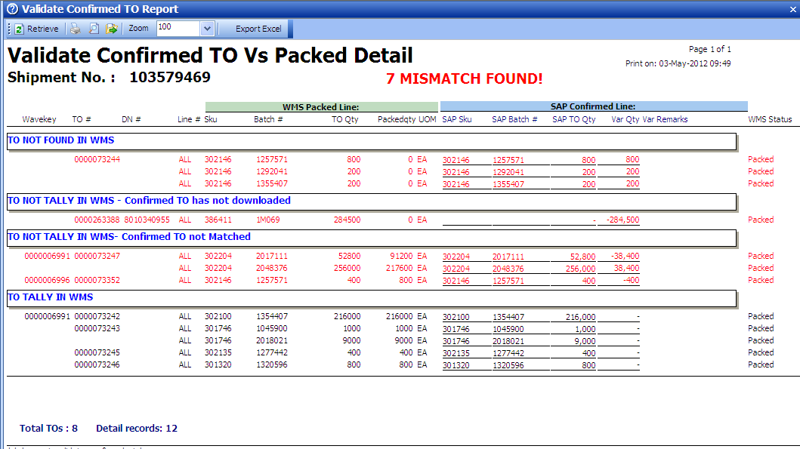

Sample matching report without variance:
